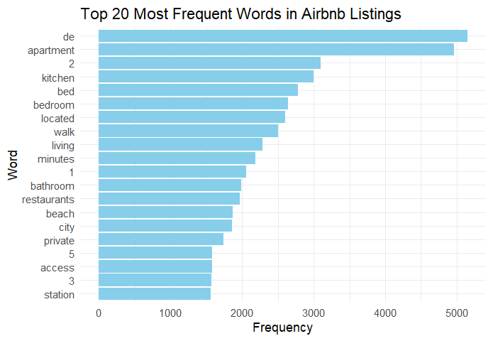

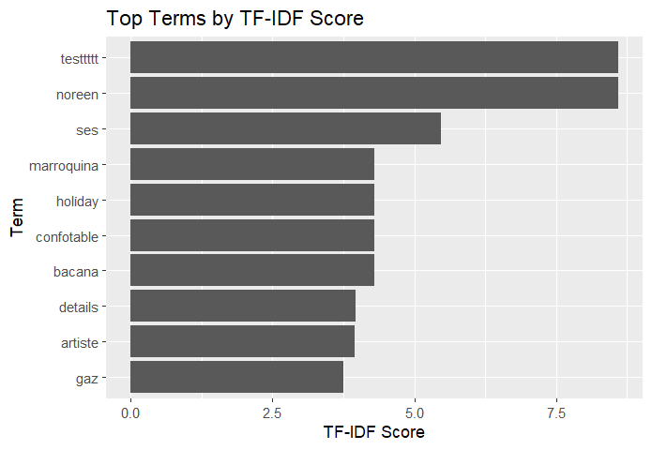

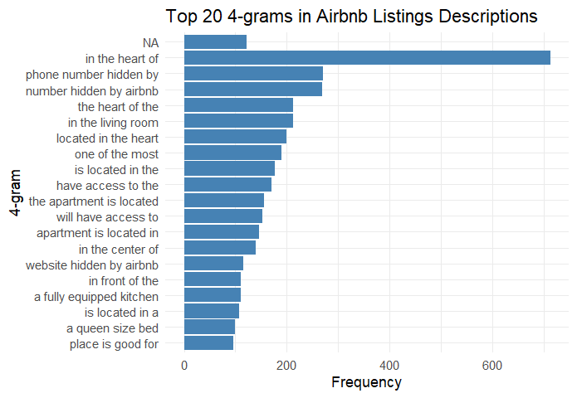

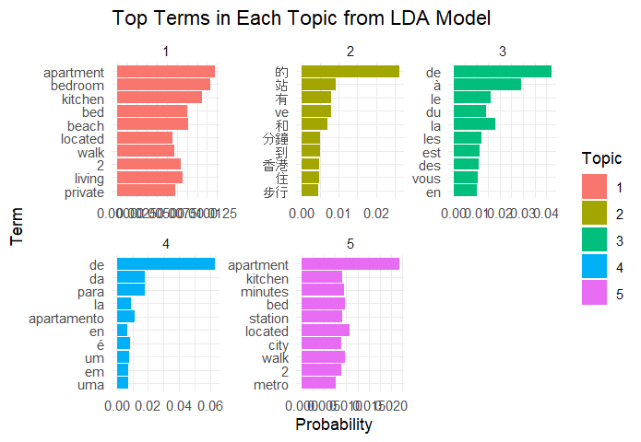

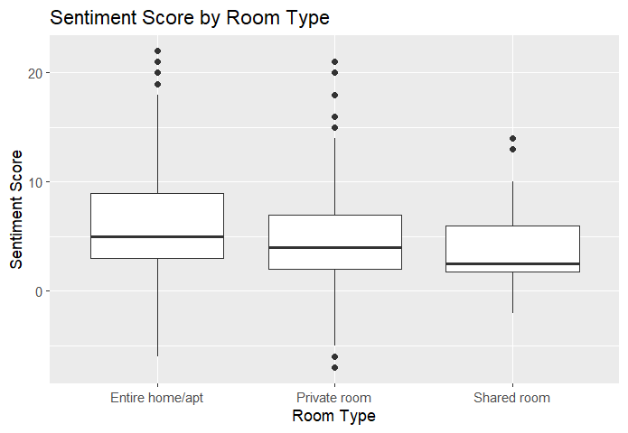

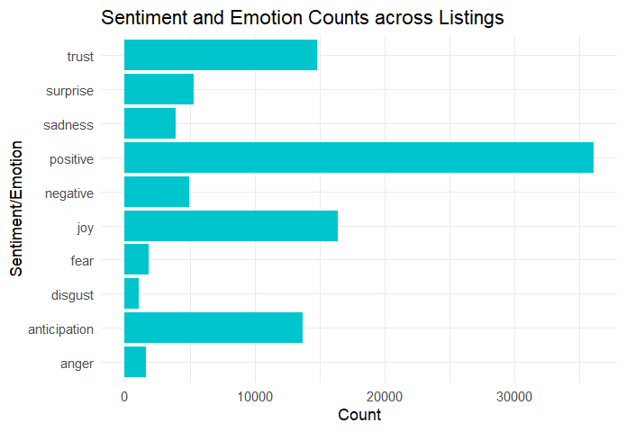

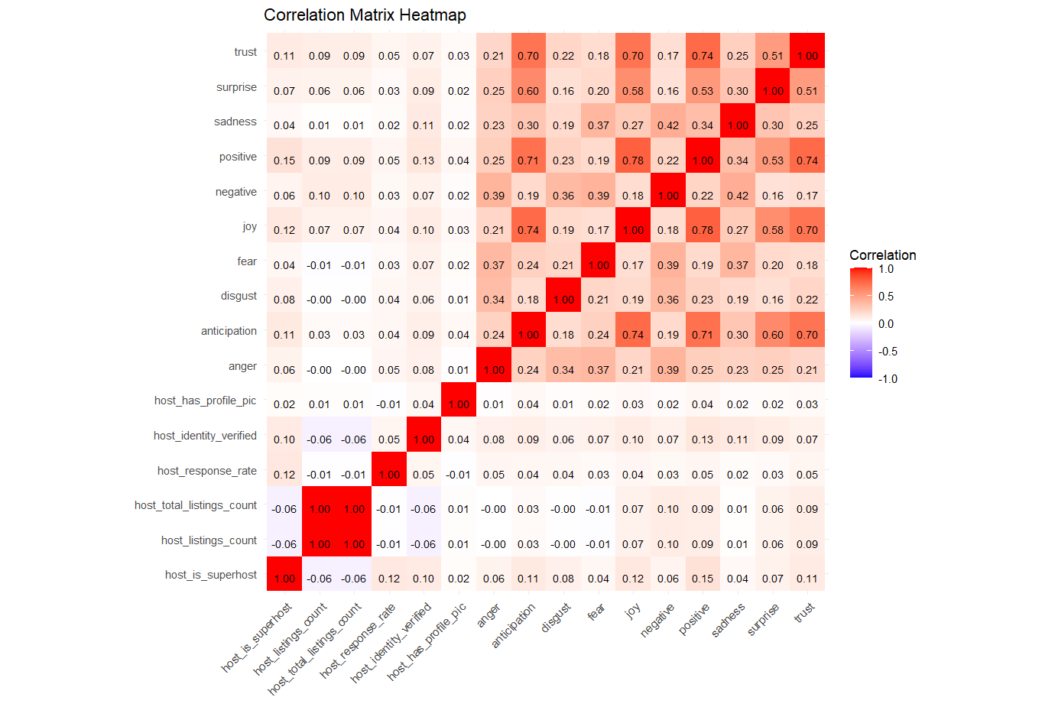

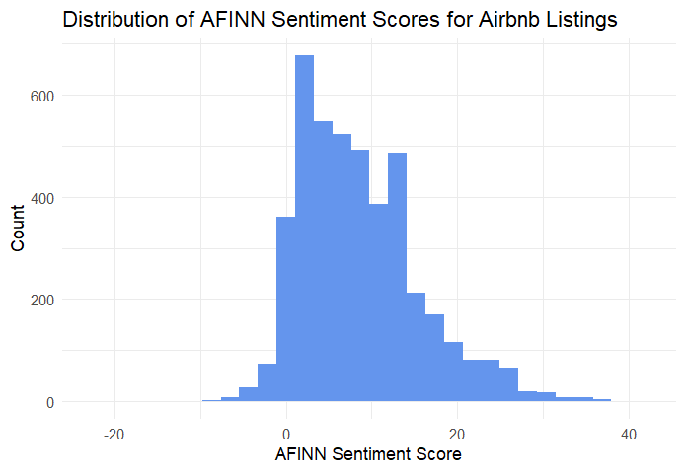

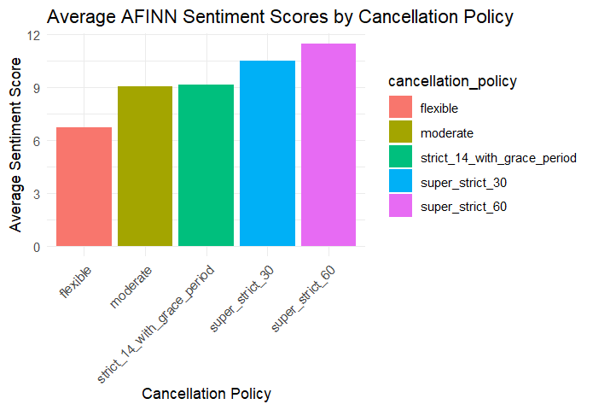

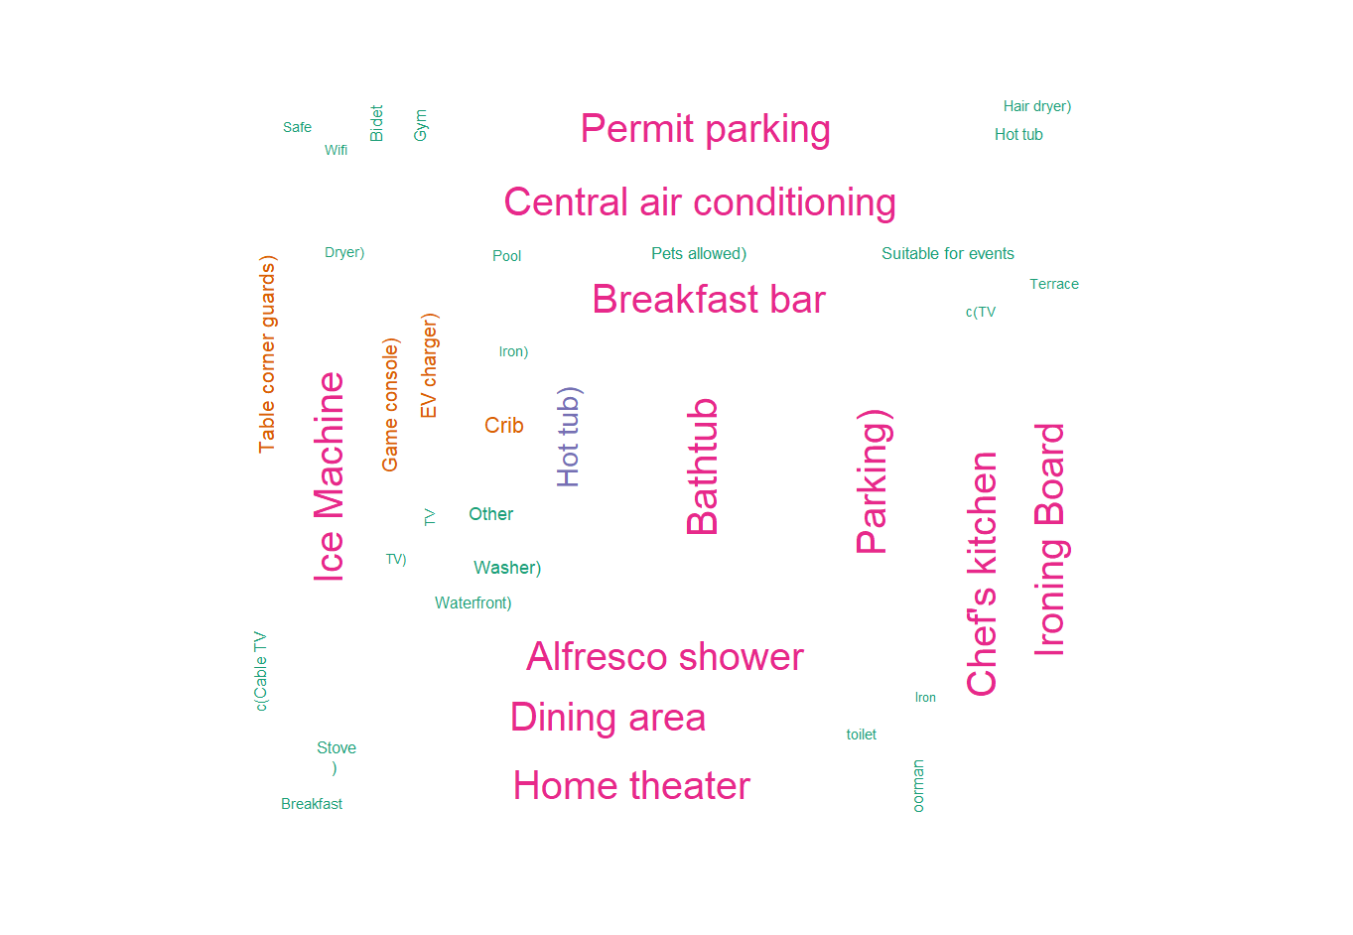

Tableau Data Viz:

